**Data Analytics for e-Business Assignment 2**

**Assignment 3.0**

**Computer-aided Decision Making**

**Abban Justice – (MC353070)**

**DATA MINING FOR DECISION SUPPORT**

1. **Correlation**

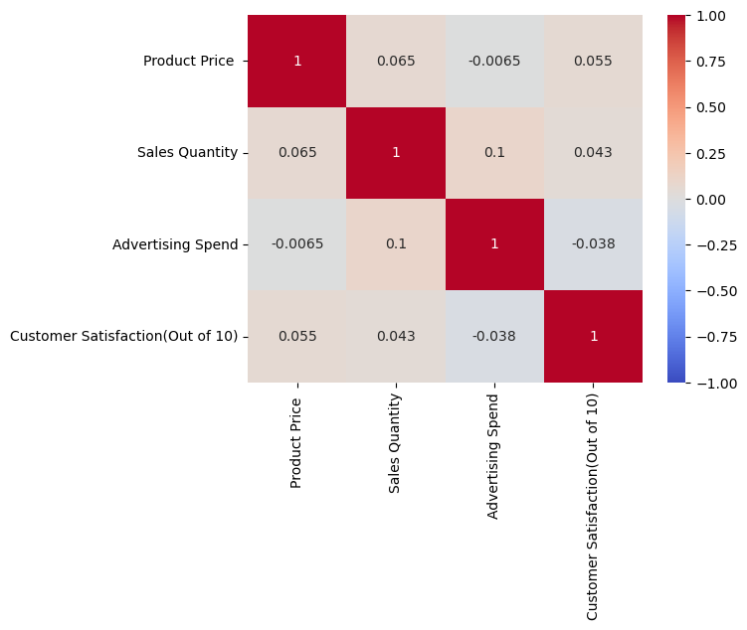

**Figure 1**

In Figure 1 above, I used the correlation to find relationships between my features. We can observe in the diagram that Product price and Sales Quantity are highly correlated. Here we can say that if my business is to sell more Jelly products it’s going to depend on the price of the product. The lower or average the price, the more people purchase but the higher the price, the fewer people purchase. This can aid us when making pricing decisions for my product.

1. **Association Rule Mining**

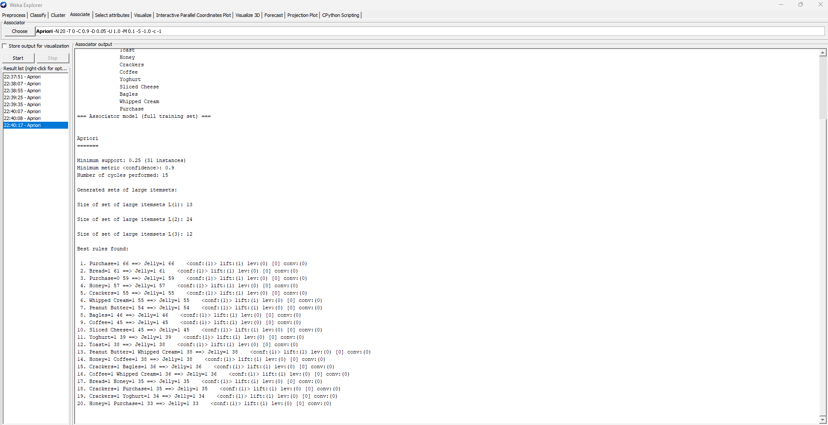

**Figure 2**

In figure 2 above, I used association rule to discover patterns and relationships within my datasets by analysing the co-occurrence and dependencies between different items or variables. This analysis will help me identify relationships between products frequently purchased together. In my figure above, we can observe that customers are likely to purchase bread, honey, peanut butter, Yoghurt among others whenever they purchase Jelly. This information is valuable for strategies such as product placement, cross-selling, and targeted marketing campaigns. ­­

1. **Feature Importance**

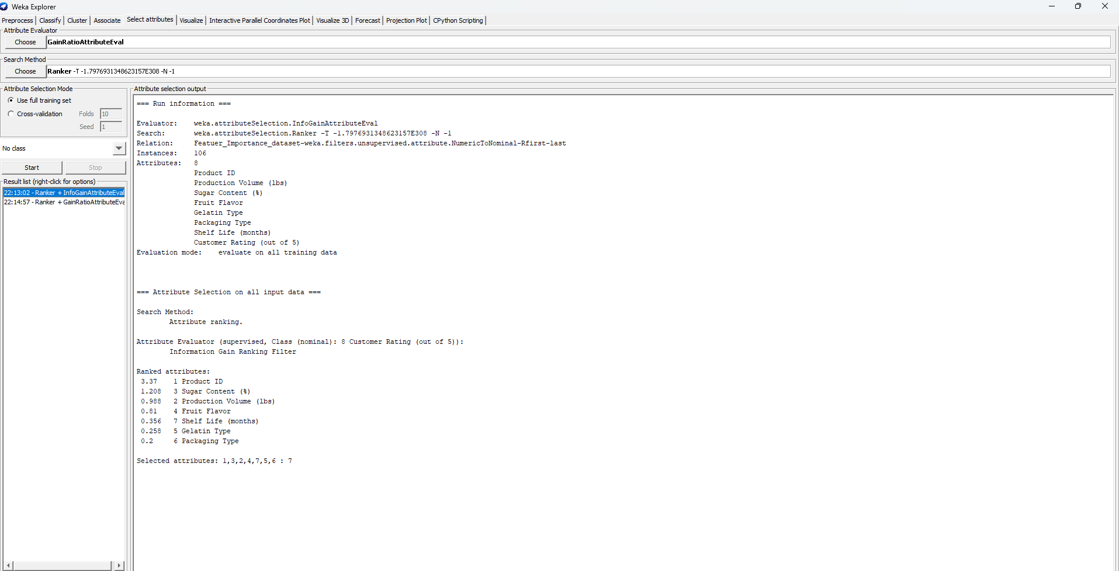

**Figure 3**

In figure 3 above we used the GainAttibuteEval in weka software to assess the relevant individual features in my dataset. According to my result we can see that the Product ID had the most impact on our analysis with the ranked value of **3.37**, followed by Sugar Content with the value as 1.208 among others. This analysis aims to determine which features contribute the most to the predictive or descriptive power on our target variable.

**Conclusion**

To conclude, we can say that we can use data mining as an aide to decision support by extracting valuable insights and patterns from datasets. It enables organizations to identify trends, predict outcomes, and make data-driven decisions. It also helps to uncover hidden relationships, detect anomalies, and optimize processes.